**JOB RECRUITMENT & HIRING MANAGEMENT SYSTEM**

**NAME: KOLLI JAGAN MOHAN RAO**

**Phase 10 : Quality Assurance Testing**

**Test Case 1: Validation Rule - Resume is Required**

* **Description/Purpose**: This test case is designed to verify a critical data quality feature. The business process requires that a candidate's resume must be on file before they can be formally considered for a role. This validation rule ensures that users cannot bypass this step, preventing incomplete application records from entering the system and saving recruiters time.

**Expected Result**: The system should block the record from being saved and display the custom error message: "You cannot create an application for a candidate until a resume link has been added to their record."

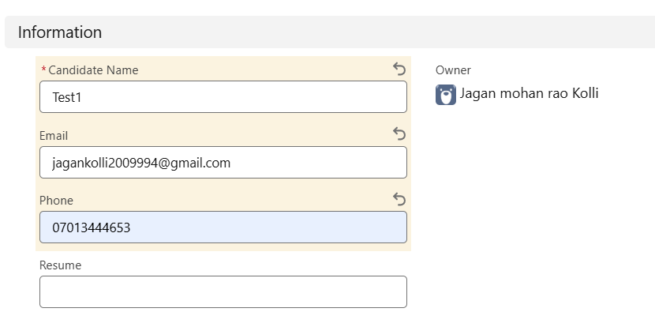

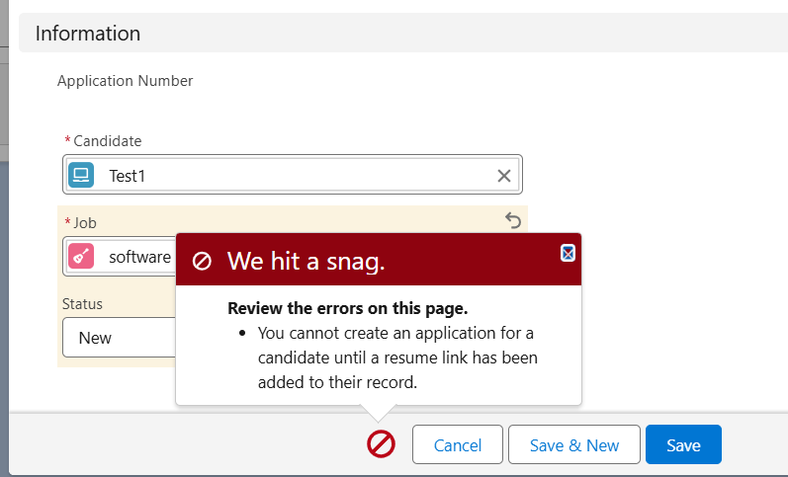

**Duplicates values triggers error**

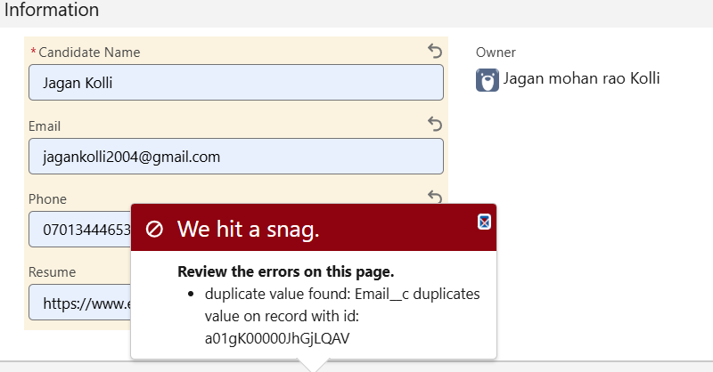

**Test Case 2: Flow - Automatic Interview Creation**

* **Description/Purpose**: This test case validates a key process automation. When a recruiter decides to move a candidate forward to the interview stage, this flow eliminates the manual step of creating a separate interview record. This test ensures the automation is working, which improves user efficiency, reduces the chance of human error, and ensures a consistent process is followed for every application.

**Expected Result**: A new Interview record should be automatically created and linked to this Application.

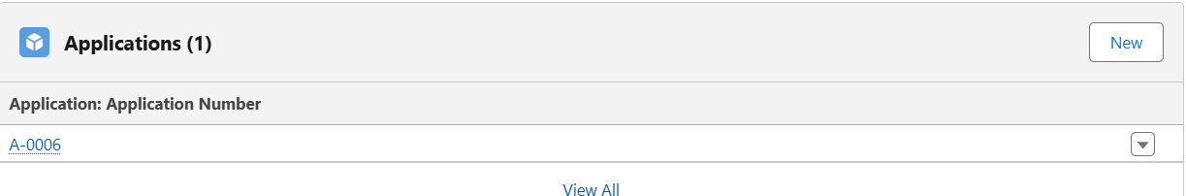

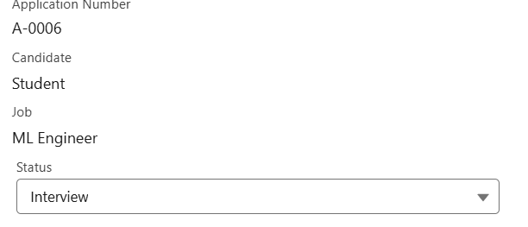

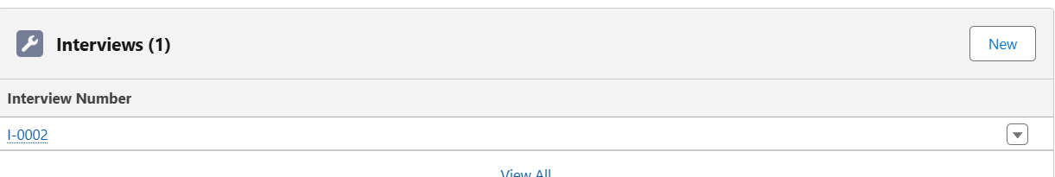

**Test Case 3: Apex Trigger - Duplicate Application Prevention**

* **Description/Purpose**: This test case verifies the custom Apex code written to handle complex business logic. A common problem in any data system is the creation of duplicate records. This Apex trigger provides a sophisticated check to ensure the same candidate is not submitted for the same job more than once. This test proves that the server-side code is functioning correctly to protect data integrity.
* **Expected Result**: The system should block the save and display the custom Apex error message: "An application for this candidate and job already exists."

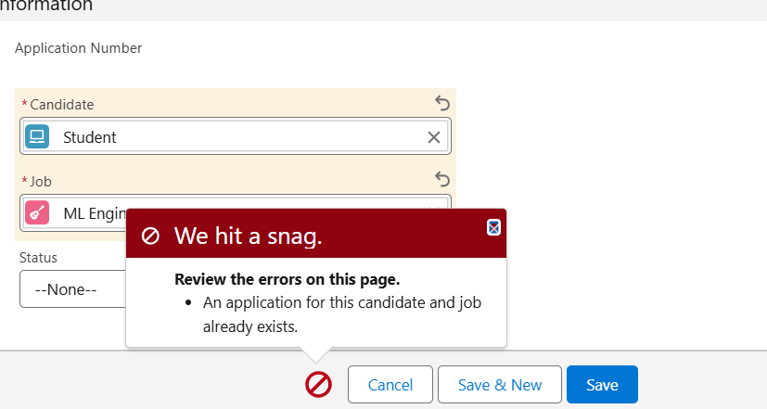

**Test Case 4: Security Model - Record Access**

* **Description/Purpose**: This is the most critical security test. It is designed to prove that the application's private sharing model works as intended. The test verifies that a Hiring Manager can only see confidential application data for jobs they personally own. This confirms that our security configuration (OWD, Record Ownership) correctly protects sensitive information and prevents users from accessing records they are not authorized to see.

**Expected Result**: Priya Sharma should only see the Application record(s) related to the job she owns. All other application records should be hidden from view.

**Job records in admin**

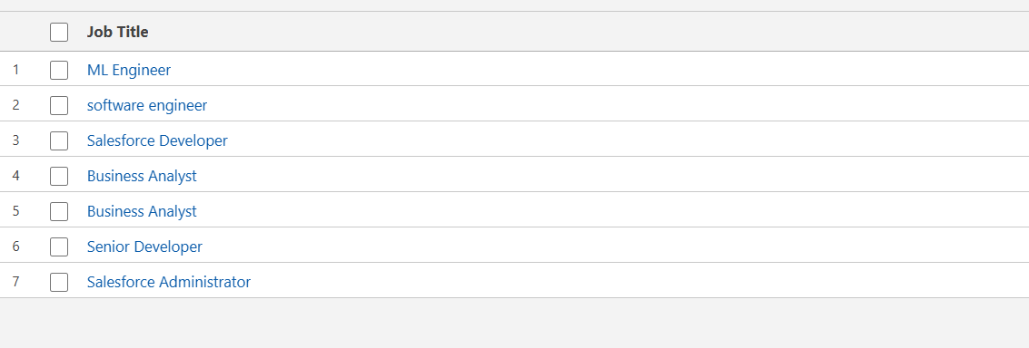

**Job records assigned or owned to Priya sharma The HR**

